Bereavement Services
Hull City Council
Chanterlands Crematorium
Chanterlands Avenue
Hull
HU5 4EF
Tel: 01482 614976
Email: bereavement.services@hullcc.gov.uk

Memorial Application

No work shall commence until the application is approved.
Please note, we can only process fully completed application forms. These must be submitted with ALL of the required information / documentation detailed below. Incomplete applications will be returned to you without processing.
An application is only complete and should be submitted when you can place a tick in every box below:

Memorial Application Checklist:
I am confirming that the following information / documentation has been submitted along with this memorial application form:
Please tick
Copy of the deed is enclosed
Payment made – amount and receipt number provided here:…………………………………………………………………..
Fully completed application form – check page 4 (incomplete applications will be returned)
Mason appears on HCC accredited list
Applicant has signed declaration at point 13 on the additional notes page
Old base has been removed and disposed of away from cemetery property

PLEASE PRINT ALL INFORMATION

Cemetery: Northern/ Eastern/ Western/ Hedon Road/ Priory Woods (delete as appropriate)
Grave Number: ……………………………………………. Compartment: ………………………………………………………….
Name of Deceased: ………………………………………………………………………………………………………………………
Deed Number: …………………………………………….. Date of purchase of exclusive rights: …………………………….

TO BE COMPLETED BY DEED HOLDER (see note 9)
In accordance with the Council rules and regulations, I hereby apply for permission to undertake monumental work. I agree to have any memorial examined for safety purposes on a basis determined by the Council (see note 7).
I understand that this memorial may have to be removed from the grave to facilitate subsequent burials.

Name: ……………………………………………………………………………………………………………………………………….
Address: ……………………………………………………………………………………………………………………………………
Post code:……………………Contact Tel No:……………………………Email:……….…….……………………………………..
Signed: ………………………………………………………………. Date: ……………………………………………………………

TO BE COMPLETED BY THE MONUMENTAL MASON
I / We agree to comply with the Council’s rules and regulations regarding memorials. I / We shall guarantee all workmanship to be free from major defect for a period of …….. years (minimum 10 years).

Name: ……………………………………………………………………………………………………………………………………….
Address: ……………………………………………………………………………………………………………………………………
………………………………………………………………………………………………………………………………………………..
Signed: ………………………………………………………………. Date: ……………………………………………………………
I sign above to confirm that the works will be carried out in full accordance with the NAMM code of working practice

Company registration number: …………………………………. Fixer number: ……………………………………………….
Please insert one of the registration numbers below: Fixer qualification:
(We cannot process the memorial application without one) BRAMM: ………………………………………………………
NAMM registration number: …………………………………….. RQMF: ………………………………………………………...
BRAMM registration number: …………………………………... C&G: …………………………………………………………..
RQMF registration number: ……………………………………... NVQ: …………………………………………………………..
Memorial Details

Tick the box to describe the nature of the job to be undertaken

New Lawn Memorial |  | New Book/ Tablet Memorial |  | Replacement Memorial
Add Inscription |  | Clean/ Repair |  | Refix to NAMM Standards

Proposed Inscription

…………………………………………………………………………………………………………………………………………………

…………………………………………………………………………………………………………………………………………………

…………………………………………………………………………………………………………………………………………………

…………………………………………………………………………………………………………………………………………………

…………………………………………………………………………………………………………………………………………………

…………………………………………………………………………………………………………………………………………………

…………………………………………………………………………………………………………………………………………………

Additional Information (including design – use box below, materials, colour and finish of stone,
method of installation, fixing practices, size of dowels to be used etc)

…………………………………………………………………………………………………………………………………………………

…………………………………………………………………………………………………………………………………………………

…………………………………………………………………………………………………………………………………………………

…………………………………………………………………………………………………………………………………………………

…………………………………………………………………………………………………………………………………………………

…………………………………………………………………………………………………………………………………………………

…………………………………………………………………………………………………………………………………………………

…………………………………………………………………………………………………………………………………………………

…………………………………………………………………………………………………………………………………………………

Note: If the design, materials, fixings, dimensions and inscription are not provided the application will be deemed as incomplete.

Use this box to illustrate the proposed design of memorial (a simple sketch is sufficient):

Memorial Details (continued)
Note: You need to provide the following details if this permit application is for a new / replacement lawn memorial
(Adult or Infant)
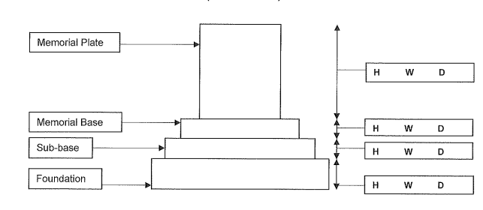

Overall Height of Memorial = Enter dimensions in boxes above
All dimensions are in inches/ centimetres/ millimetres (delete as appropriate)

Note: Please ensure that you do not exceed the maximum permitted dimensions as specified in the
Memorial Mason Scheme Handbook as your application will be rejected.

Please indicate the position of the stainless steel fixing dowels and the ground level on the diagram above.
Note: Foundation is below ground and level at the highest point.

Note: You need to provide the following details for permit applications for a new / replacement book-style memorial
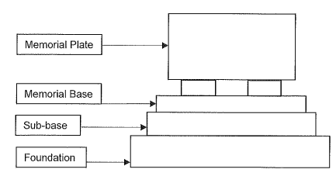
H W D
H W D
H W D
H W D
H W D
Memorial Rests
Overall Height of Memorial = Enter dimensions in boxes above
Note: Please ensure that you do not exceed the maximum permitted dimensions as specified in the
Memorial Mason Scheme Handbook as your application will be rejected.

Please indicate the position of the stainless steel fixing dowels and the ground level on the diagram above.
Note: Foundation is below ground and level at the highest point.

Memorial Details (continued)

Note: You need to provide the following details if this permit application is for a new / replacement tablet-style memorial
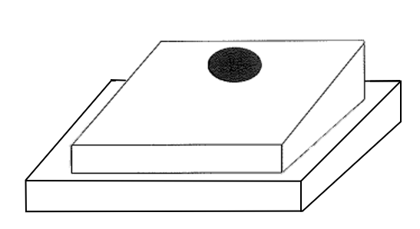
Plate (Maximum HxWxD)
H W D
Sub-Base/Foundation
H W D
Enter dimensions in boxes above

Note: Please ensure that you do not exceed the maximum permitted dimensions as specified in the
Memorial Mason Scheme Handbook as your application will be rejected.

Name of Approved Ground Anchor System used:

Nettlebank EZY Fix Nettlebank LOK-DOWN Blastshop System
CCA S/S Threaded Peg & Tube Other (please specify):

Composition of Foundation – to conform to BS8415:

Any other details should be attached on a separate sheet.

OFFICE USE – If you cannot place a tick in each box below to confirm the information is provided, the application is incomplete and must be returned:
DESIGN |  | MATERIAL |  | FIXING |  | DIMENSIONS |  | INSCRIPTION

Additional Notes

- Permit applications will only be accepted from memorial masons who are currently on the Council’s memorial masons accredited list.

- Only fully completed permit applications will be accepted for processing. Incomplete applications will be rejected.

- Every headstone or memorial erected over a grave space should bear the name of the mason, the number of that grave space and the compartment in which the grave space is situated.

- All memorials must be of a material approved by the Council i.e. natural granite, marble, or other materials as may be approved by the Council. Metal and plastic are not suitable materials for use in memorials.

- All memorials must be installed to the most recent NAMM standards.

- A minimum period of 12 weeks must be allowed after the interment date before a memorial is erected. This is due to grave settlement. Note: The ground may take up to 6 months to settle if the last interment was larger than standard, it is the Monumental Masons responsibility to determine after the 12 weeks minimum what is suitable, the City Council suggests a 6 month minimum in these cases.

- In order to comply with Health and Safety requirements, the Council will inspect memorials for stability on a regular basis. Any memorials found to be unstable will be temporarily made safe by the most suitable means, this may include laying it down. Reinstatement is the responsibility of the deed holder.

- The deed holder on signing this agreement allows Hull City Council to dismantle and inspect the memorial at any time without prior notice.

- Deed holder details must be established and determined without doubt. A copy of the deed must be provided along with any application in order for the permit to be processed.

- Old bases must be removed by the Monumental Mason who is working at the grave. Under no circumstances should an old base be left discarded within the cemetery. These can cause serious Health and Safety risks failure to do so may result in a charge being levied against the mason for removal.

- Hull City Council recommend that insurance is taken out to cover the memorial.

- Full rules can be found on the Council’s website and in the Council’s Memorial Mason Scheme Handbook.

- Memorials found to be in breach of the Cemetery or Memorial Mason Scheme rules will be removed without notice and stored for 28 days. Deed holders will be notified in writing.

- Please sign below to fully complete the application and to confirm that you understand and accept the terms and conditions of this permit application.

SIGNED: Date:

FOR OFFICE USE:
Cemetery: | Grave Number: |  | Compartment:
Interment Date: | Grave Type: |  | Grave Size:
Comments:

Permit Approved By: |  | Date Approved:
Permit Cost: |  | Permit Number:

Bereavement Services Privacy Notice

Overview
The information that you provide is processed in accordance with the Data Protection Act 2018. The data controller for this information is Hull City Council.

Why we need to process your personal data
We will use the information you give us to provide a burial or cremation service. We process personal information to comply with our obligation as a Local Authority to perform tasks which are carried out in the public interest; this includes public health funerals, in line with Section 46 of the Public Health Act 1984 and our non-statutory obligation to deliver bereavement functions to meet the needs and expectations of residents in the City. We also process personal information to deliver services under contracts with persons in respect of funerals, burials and cremations.

We hold information about:
- Deceased individuals and their relatives/ friends who are arranging the funeral
- Employees of other organisations involved in burial/ cremation arrangements, such as stone masons, funeral directors.
- Other public sector professionals such as the police, NHS etc.

The types of information we hold includes:
- Names and contact information
- Family members relationship to the deceased
- Medical/ special requirements of guests attending ceremonies
- Warning indicators about individuals attending ceremonies
- Religious beliefs of family and ceremony preferences

Information Sharing
We receive information from:
- Family/ friends/ acquaintances of the deceased and their representatives
- Businesses
- Other public sector professionals i.e. police, NHS
- Hull City Council staff

We may share information with third parties who are involved in the burial/ cremation process, such as ministers, funeral directors etc. but they will not be allowed to use your data for any other purpose.

Retention Period
Cremation paperwork is retained for 15 years after the cremation date. Burial paperwork is retained for 10 years after the burial date. Baby cremation papers and enquiries, memorial leases and cremation and burial registers are retained permanently.

Your Rights
You have the right to request access to the personal information we hold about you, to be informed about the collection and use of your personal information, for the information held to be corrected (where the law permits) and to request us to restrict the processing of your personal information. In certain circumstances you have the right to object to the processing of your personal information. Your information will not be subject to automated decision making.

Questions/ complaints/ comments
More details about how Hull City Council uses personal information can be found on our website: http://www.hull.gov.uk/help/privacy-notice. If you have any questions or concerns about the collection, use or disclosure of your personal information please contact please contact:

Data Protection Officer
Hull City Council, Room 11, The Guildhall, Hull, HU1 2AA
Information@hullcc.gov.uk

You also have the right to complain to the regulator:

Information Commissioner's Office
Wycliffe House, Water Lane, Wilmslow, Cheshire, SK9 5AF

Telephone: 0303 1231113 (local rate) or 01625 545745 if you prefer to use a national rate number

Online enquiries: https://ico.org.uk/global/contact-us/email

